FUND FOR LOCAL COOPERATION
ATTACHMENT 3 FOR PRIVATE SECTOR APPLICANTS ONLY: INFORMATION FORM

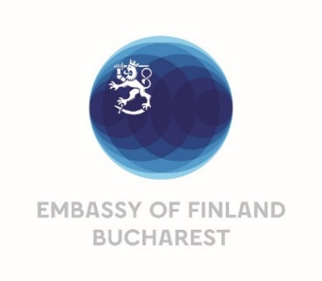 | Please read and complete this form carefully. If any information is missing, your application may be rejected. Instructions and the required attachment forms are available at the Call for FLC Proposals https://finlandabroad.fi/web/mda/frontpage  Fill in all applicable fields in English and sign the form. Return the form together with FLC application form, attachment 1. Project Budget and attachment 2. CV(s) to the projects.buk@formin.fi

- APPLICANT

1.1 Company full legal name:

1.2 Address:

1.3 City:

1.4 Postal Code:

1.5 Country:

1.6 Telephone number:

1.7 E-mail address:

1.8 Website address:

1.9 Name of contact person:

1.10 Contact person’s title and area of responsibility:

1.11 Contact telephone number:

1.12 E-mail address:

- LEGAL STATUS

2.1 Business identification number – tax code:

2.2. Country registered in:

2.3 Year of establishment:

2.4 Form of ownership or legal structure:
General partnership  Limited partnership  Limited company  Public limited company | Cooperative  Association or foundation  Other:

2.5 Ownership structure:
Owner(s) | Share %

Note: If company owners include companies, please also provide their full ownership structures below
(you can provide a separate annex if preferred):

2.6 Company structure: If the company is part of a group, please provide group ownership structure below (you can provide a separate annex if preferred):

Provide the applicant company’s possible ownership (% share) in other companies:

- BUSINESS / ACTIVITY

3.1 Main economic or other activity of applicant:

3.2 Main products:

3.3 Main markets:

3.5 Year(s) in business:

3.6 Number of employees:

3.7 Previous full-year turnover:

3.8 Previous full-year end total assets:

3.9 Size of the company

3.10 Business sector / industry of applicant:
Agriculture and food processing  Construction  Crafts  Educational services  Electrical engineering  Electronics  Energy  Environment  Fishery and fish products  Health and pharmaceutical  Information and communication technology | Manufacturing engineering and machinery  Metal and industry engineering  Packaging and materials  Research and innovation  Rubber and plastics  Services  Textiles and clothing  Tourism  Transportation  Forestry, wood and paper  Other:

I, the undersigned, being the person responsible in the applicant organisation for the action, certify that the information given in this application is correct and accurate.
The applicant and undersigned agrees that if the project proposal is successful, the following information contained in this form may be made public for reporting purposes: name of the applicant, business sector, amount of support granted, name and target country of the project, and short project description. Disclosure of information may also be required under applicable law or by relevant authorities.
Signature: | Title or position:
Name: | Date and place:

