C U R R I C U L U M V I T A E 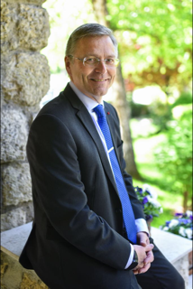

Family Name: IKONEN
First Name: Pertti
Nationality: Finnish
Date of Birth: 28 November 1959
Marital Status: Married to Ms. Pia-Susanna Purra
Daughter and Son
Education: LL.M, Helsinki University, 1988

Work Experience:

2019 - Ambassador of Finland to the Caribbean
Ministry for Foreign Affairs (MFA), Helsinki, Finland

2015 - 2019 Ambassador of Finland to the Republic of Serbia,
Montenegro and North Macedonia, Belgrade, Serbia

2010 - 2015 Ambassador for Aid for Trade, Information Society
Department for Development Policy, MFA

2005 - 2010 Minister Counselor, Deputy Head of Mission
Embassy of Finland, Copenhagen, Denmark

2002 – 2004 Director
Division for Non-Governmental Organizations
Department for Development Policy, MFA

2001 – 2002 Special Adviser to the Under-Secretary of State
MFA

1997 – 2001 Counsellor
Embassy of Finland, Tallinn, Estonia

1995 – 1997 Deputy Head of Mission, First Secretary
Embassy of Finland, Caracas, Venezuela

1995 Second Secretary
Political Department, MFA

1993 – 1995 Senior Programme Officer
Unit for International Financial Institutions, MFA

1991 – 1993 Programme Officer
Division for Non-Governmental Organizations, MFA

1989 – 1991 Lawyer
Division for Agriculture and Forestry,
Department for Development Co-operation, MFA

Decorations: Knight, 1st class, Order of the Lion, President of Finland 2005
Knight, 1st class, Order of Danneborg, Queen of Denmark 2010

Languages: Finnish: mother tongue
Swedish, English: fluent
Danish, Spanish: very good
French, German, Estonian: good
Serbian: basics

Personal Interest: arts, photography, summer-house life, skiing, karate

